12.61: At Sacramento, the gravity force on you is 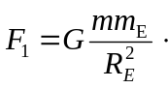
At the top of Mount Everest, a height of 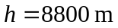above sea level, the gravity force on you is


